Spawn Tutorial

This shows how to spawn in objects via a key press to be dropped down.

1. Create a new scene

Start by creating a new scene called Spawn.

Add a 3D cube and name it SpawnQ.

Give this box a box collider.

1. Scripting

Create a new C# script called SpawnQ.

This script will allow us to spawn cubes from the SpawnQ cube:

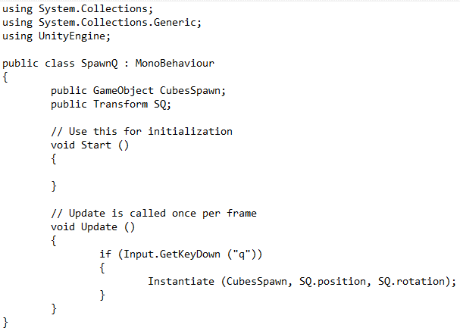

The script looks for the pressing of the q key on the keyboard and if the q key is pressed a cube is instantiated (spawned) from whatever the script is attached to.

1. Attaching the script and components

Now after saving the script switch back to the Unity editor.

Create another 3D cube called CubesSpawn and also create a new folder in the assets folder of unity the project called Prefabs.

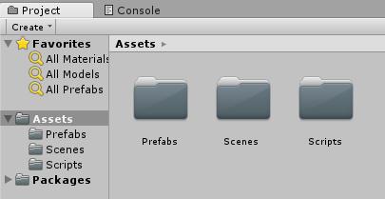

Place the newly created CubesSpawn cube into the Prefabs folder for unity to create the cube into a prefab.

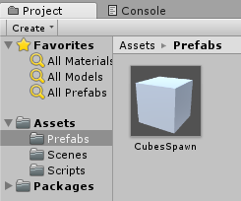

After attaching the SpawnQ script to the SpawnQ cube, attach the CubesSpawn prefab from the prefab folder to the CubesSpawn slot in the inspector. For the SQ slot attach the SpawnQ object from the hierarchy.

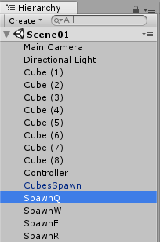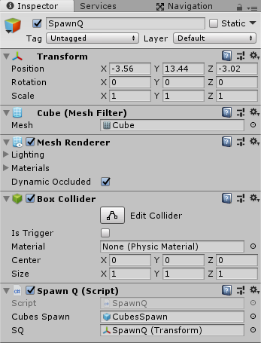

After this run the project and pressing q should instantiate (spawn) a cube every time q is pressed.